WIRESHARK RESULT

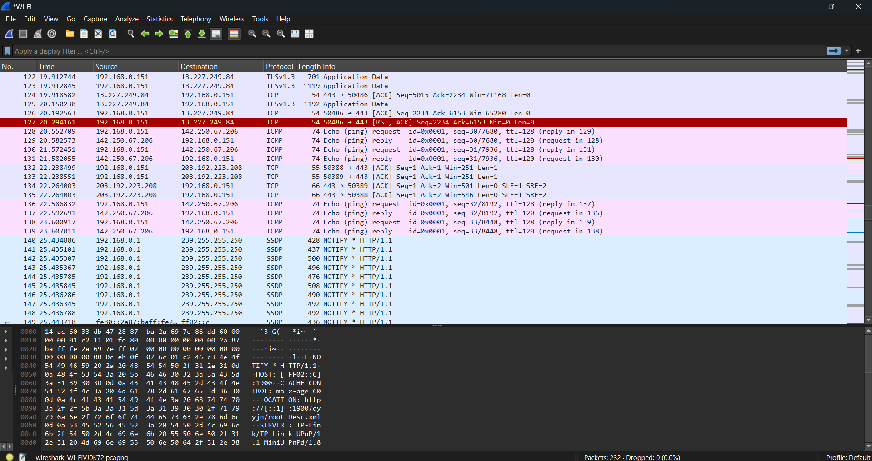

COMMANDS USED

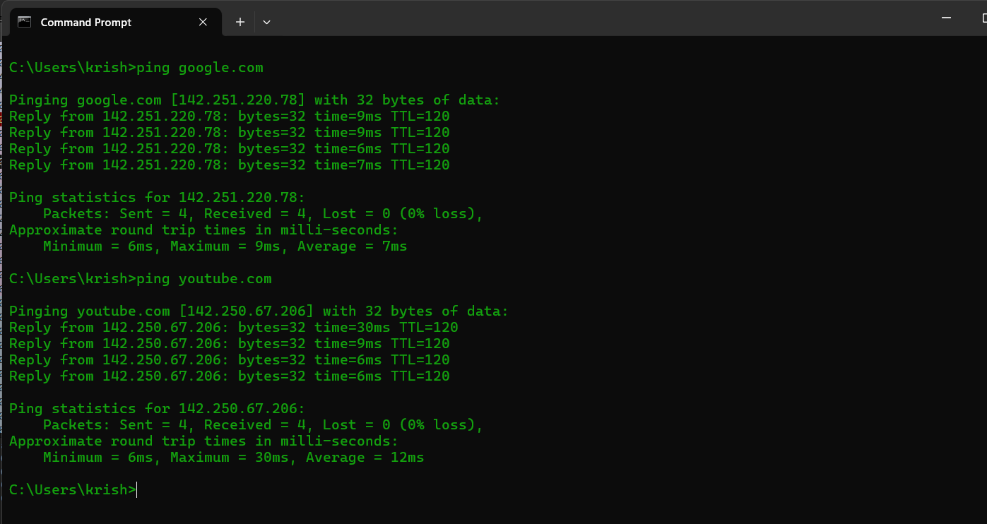

FILTER BY HTTP (No Packets since only pinged youtube.com and google.com)

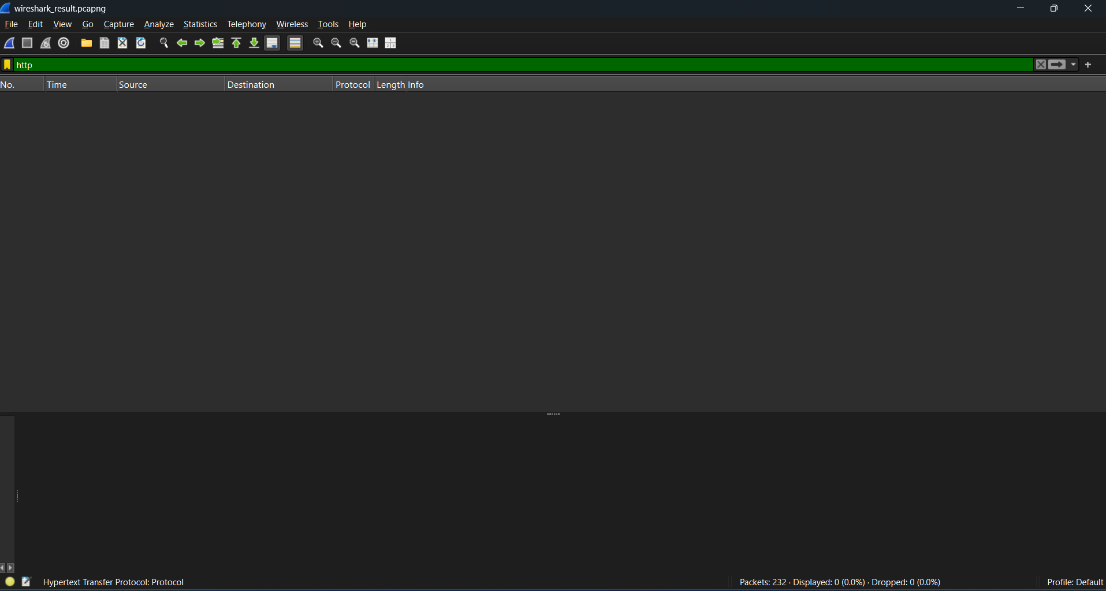

FILTER BY DNS (12 Packets i.e. 5.2% of result captured)

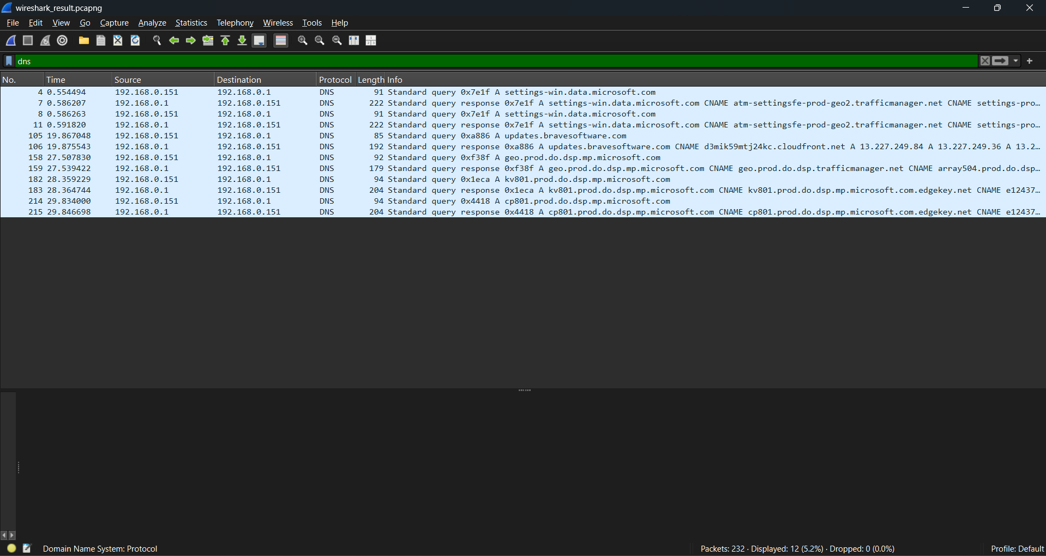

FILTER BY TCP (171 Packets i.e. 73.7% of result captured)

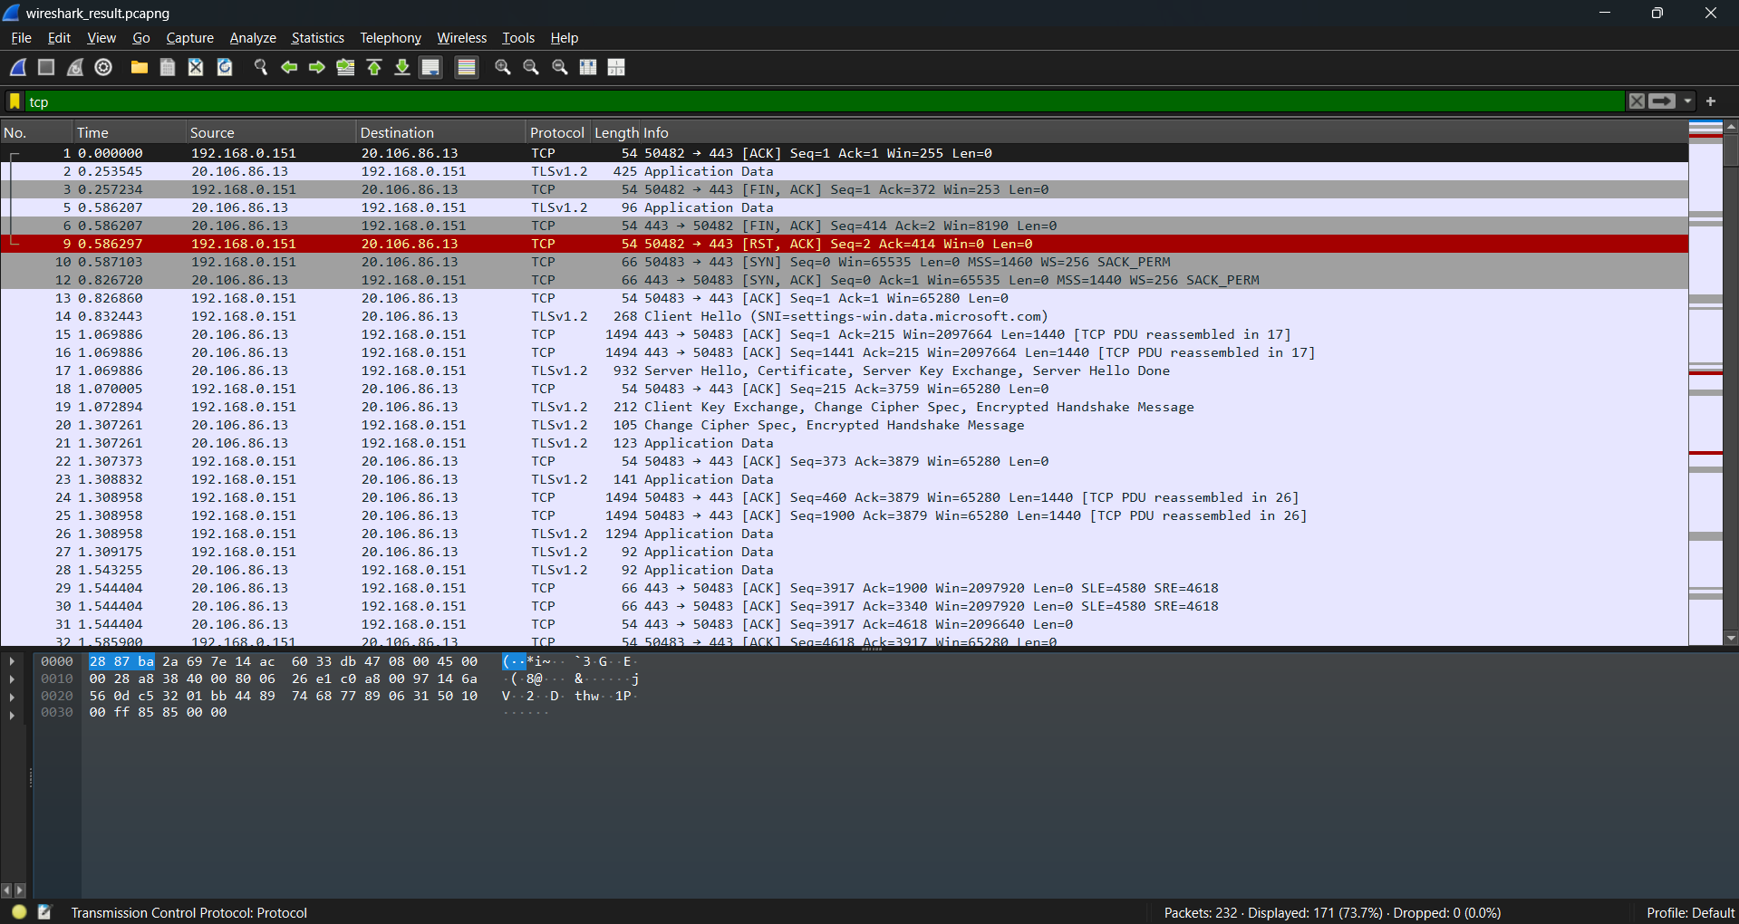

FILTER BY UDP (43 Packets i.e. 18.5% of result captured)

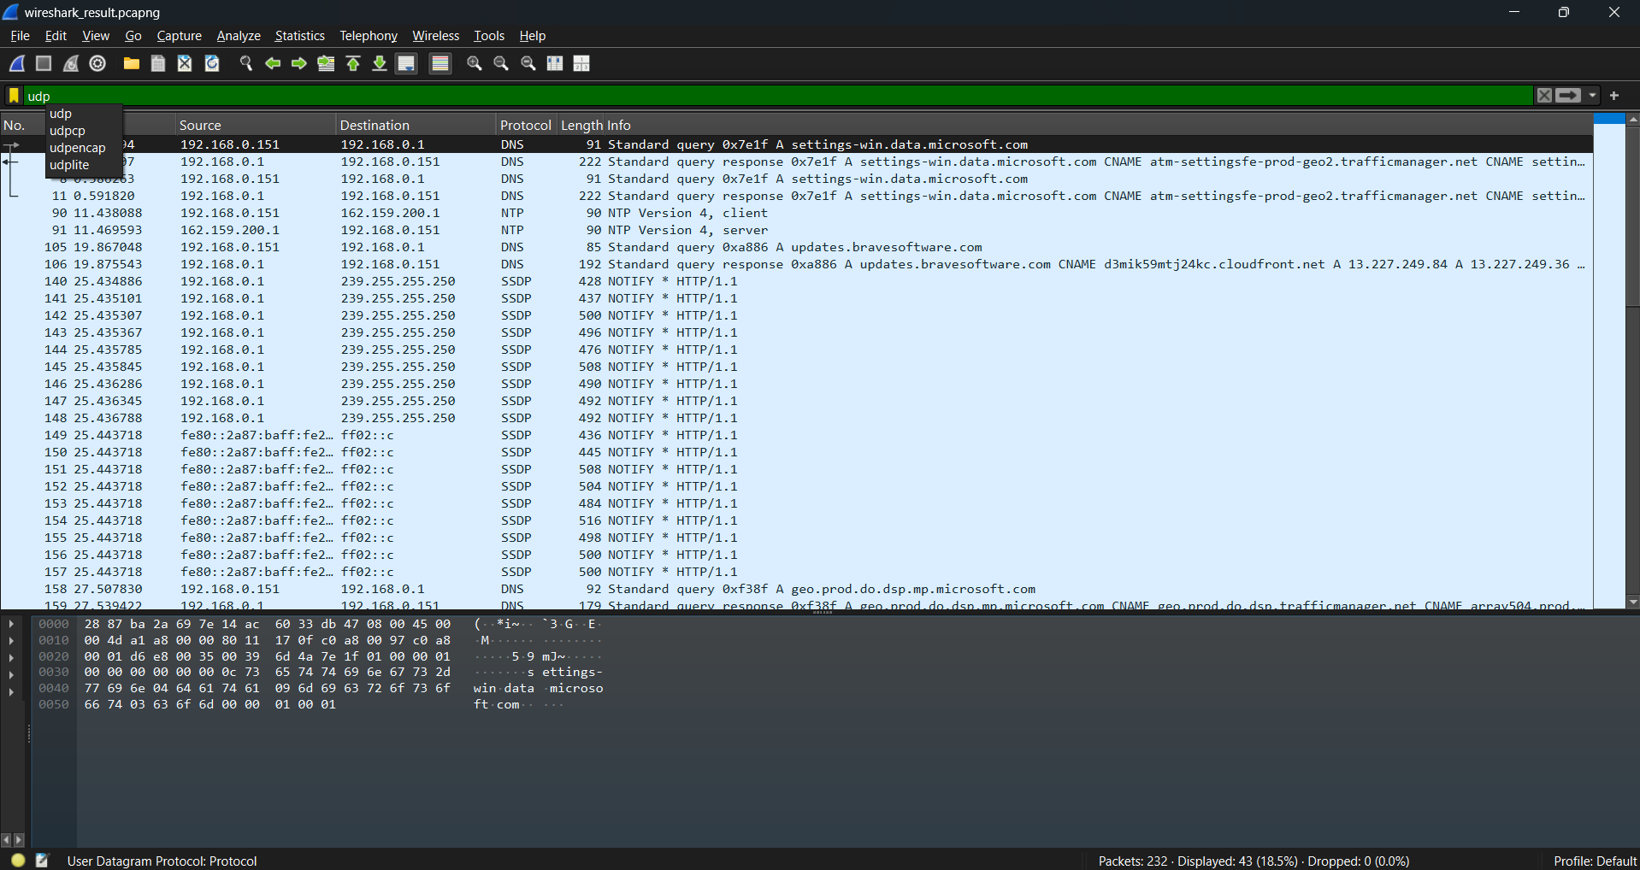

FILTER BY SSDP (27 Packets i.e. 11.6% of result captured)

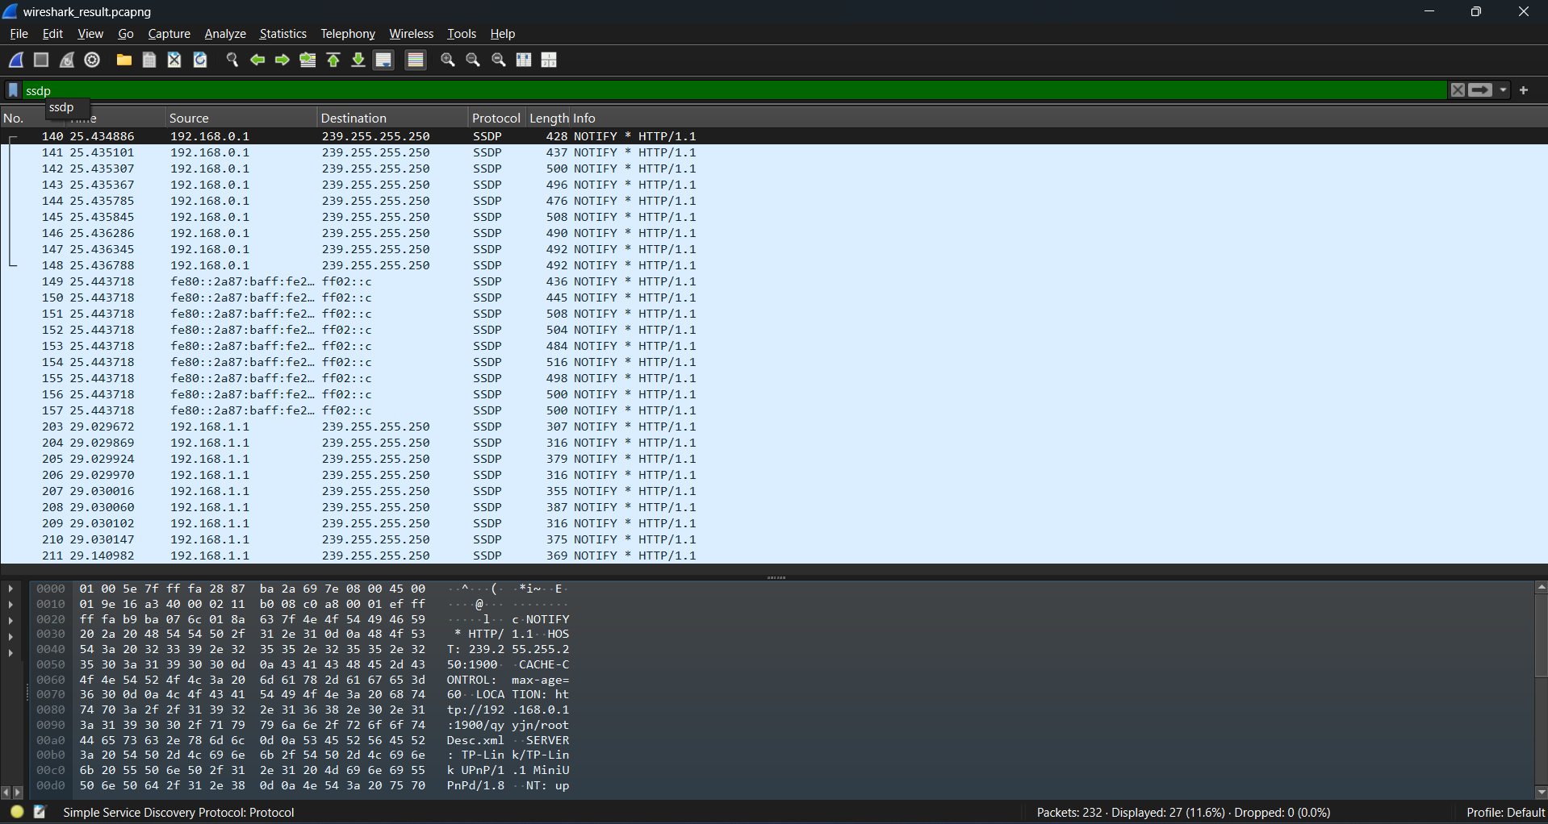

PROTOCOLS SUCCESSFULLY IDENTIFIED:

* TCP
* UDP
* DNS
* SSDP

SUMMARY

* A significant portion of the traffic involved communication with 23.212.160.122, which resolved to a domain related to Microsoft's content delivery network via Akamai. This included typical TLS handshake sequences: Client Hello, Server Hello, certificate exchange, and session establishment followed by Application Data.
* Around packet 201, I noted a TCP FIN, ACK indicating session termination from another external IP (52.167.163.114), possibly from a different completed connection.
* Another complete **TLS handshake** sequence was observed starting at packet 216, where a new connection was initiated to the same IP. The session proceeded successfully, and application data was exchanged securely.
* I also saw SSDP (Simple Service Discovery Protocol) messages being broadcast from my router (192.168.1.1) to the multicast address 239.255.255.250, which is typical for device discovery on the local network.

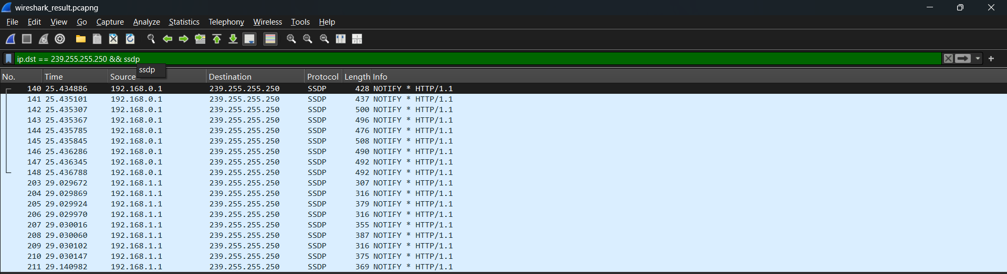

* No suspicious activity was detected. This analysis provided insight into secure TLS connection establishment, real-time DNS resolution, and local network multicast protocols like SSDP and mDNS.